Diabetes Prediction

* This is the diabetes prediction project used to predicted that how person is like to get Diabetes.

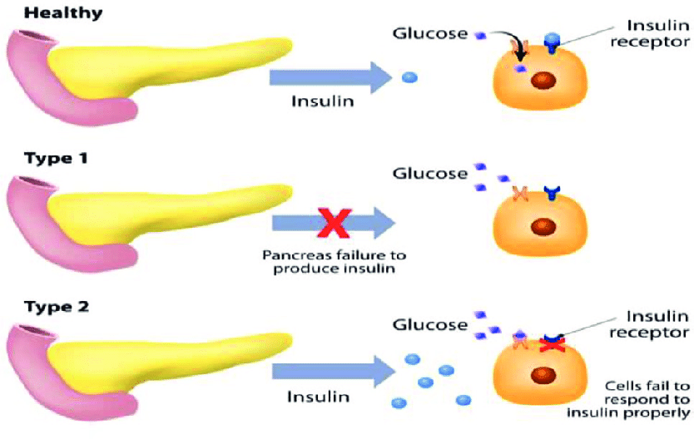

* It used to take different parameters to measure and predicted the diabetes:

|  |
| --- |
| 1. Pregnancies: |
| Home Pregnancy Test: The right way to read a pregnancy test | How to Read a Pregnancy  Test Correctly at Home | - Times of India |
|  |
| 1. Glucose: |
| Diabetes Care: What Is Normal Blood Sugar Level? Know It By Your Age |
| 1. Blood pressure: |
| 8 things to keep in mind when checking your blood pressure | CFPCN |
| Blood pressure chart showing blood pressure ranges. |
| 1. Skin Thickness: |
| Skinfold Thickness - an overview | ScienceDirect Topics |
| PDF] Skin Fold Thickness in Diabetes Mellitus: A Simple Anthropometric  Measurement May Bare the Different Aspects of Adipose Tissue | Semantic  Scholar |
| 1. Insulin: |
| Signs You Have A Blood Sugar Imbalance - Conscious Cleanse |
| 1. BMI: |
| * This is link to measure: https://www.diabetes.ca/resources/tools---resources/body-mass-index-(bmi)-calculator#:~:text=The%20formula%20is%20BMI%20%3D%20kg,most%20adults%2018%2D65%20years. |
| How to Calculate Body Mass Index (BMI) |
| 1. DiabetesPedigreeFunction: |
|  |
|  |
|  |
|  |
|  |
|  |
|  |
|  |
|  |
|  |
|  |
|  |
| 1. Age: |
| Age and gender wise distribution of Diabetes and Impaired fasting glucose |  Download Table |

* Support Vector Store: It’s one of the important Algorithm of supervised Learning.

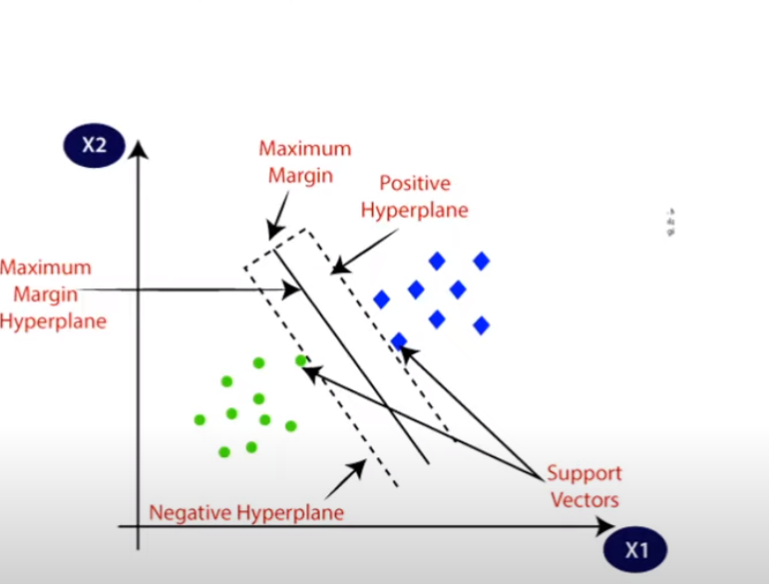

* Workflow

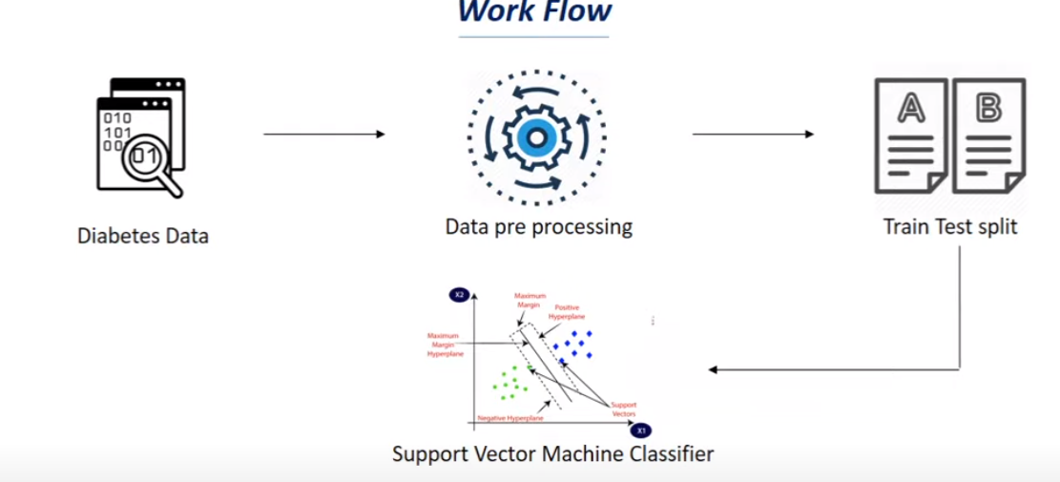

After Train the Model

